**Data Science step1**

Introduction to data and its types

Continuous data and discrete data

Nominal and ordinal data

Data Processing: -

Reading data, handling missing data, categorical data, splitting data in training and testing, Normalize data

Web Scrapping:

What is Web Scrapping, Web Scrapping processing, search elements in different ways, how to use developers tools in browser

Exploratory data analysis: -

EDA of pima Indian diabetes dataset, visualize it,

Data Transformation and scaling data: -

Rescal data , standardize data, normalize data and binarize data

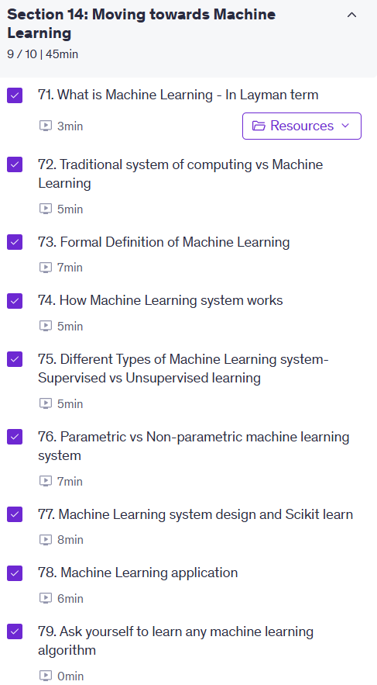

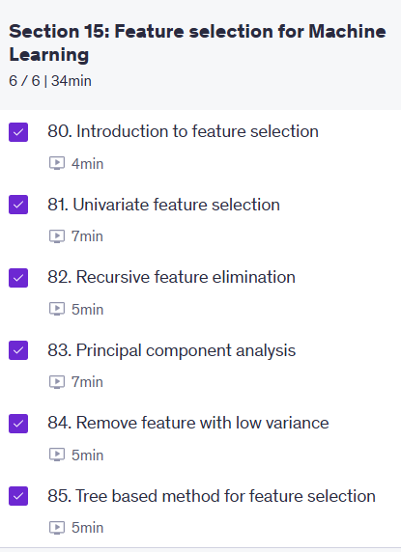

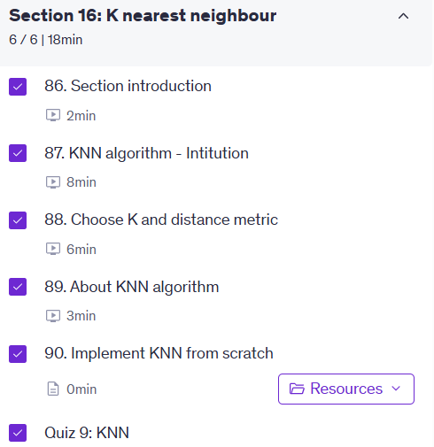

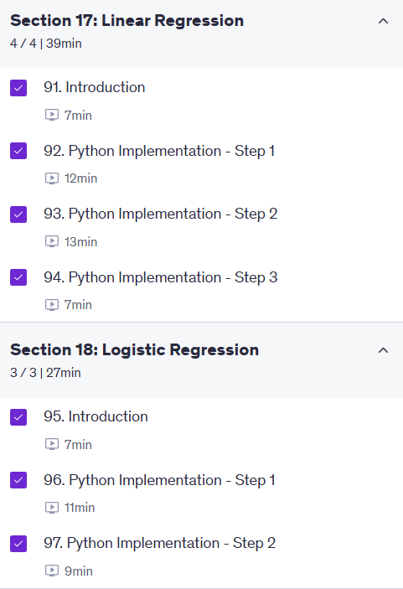



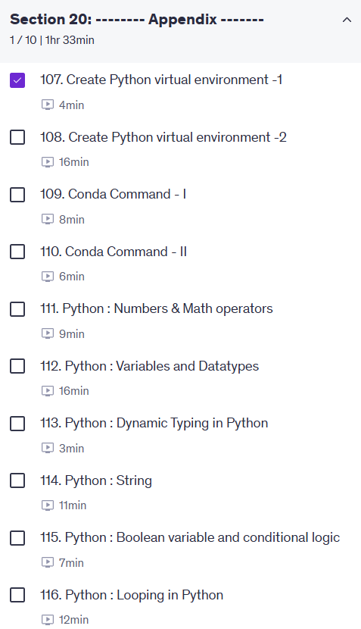

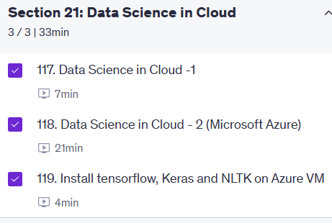

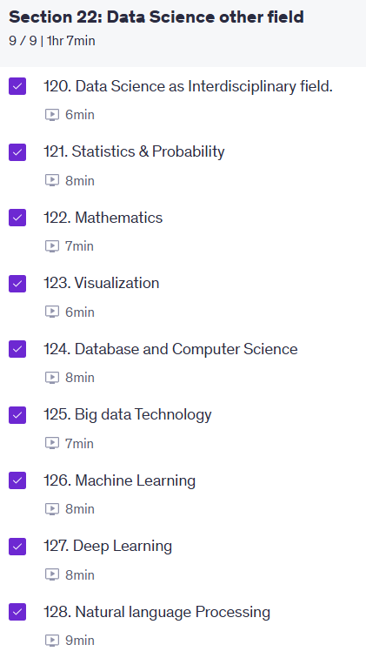

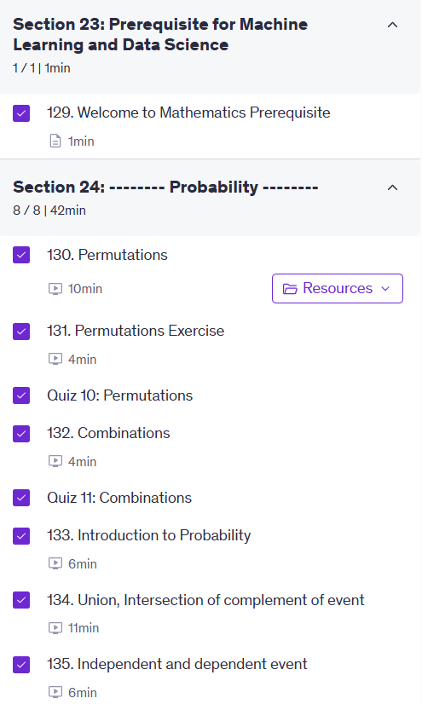

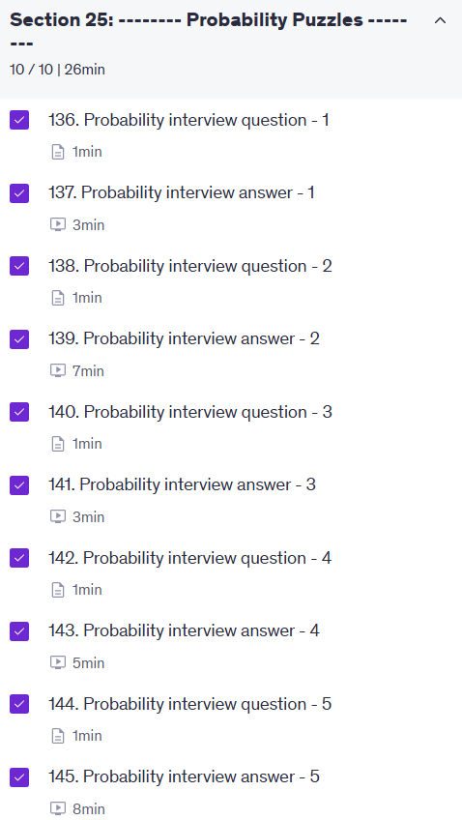

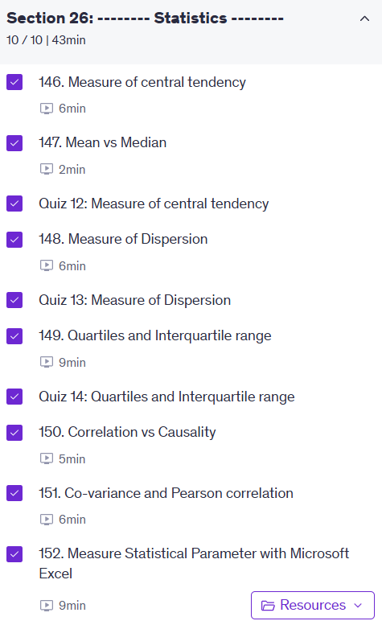

For predicting categorical output which machine learning types of algorithm used

Top of Form

In which type of machine learning technique output label has been given

* **supervised learning**
* **Unsupervised learning**

Bottom of Form

Top of Form

Predicting whether image contains cat dog or human face.

This type of problem can be solved with which type of machine learning system

* **Regression**
* **classification**

Bottom of Form

Top of Form

Predicting probability of given email is spam.

This type of problem can be solved with which type of machine learning system

* **Regression**
* **Classification**
* **Clustering**
* **Reinforcement learning**

Bottom of Form

Which system will you preferred to solve given problem below.

1. Predicting Cat or Dog

2. Find number is odd or even

3. Find shortest route between two node

4. Predict tomorrow stock price.

TS - Traditional system

ML - Machine Learning

Top of Form

Which type of machine learning I did not discuss.

* **Supervised learning**
* **Reinforcement learning**
* **Classification**
* **Unsupervised learning**
* **Regression**

Bottom of Form

<https://www.udemy.com/course/machine-learning-course-with-python/learn/lecture/16722374?start=0#overview>